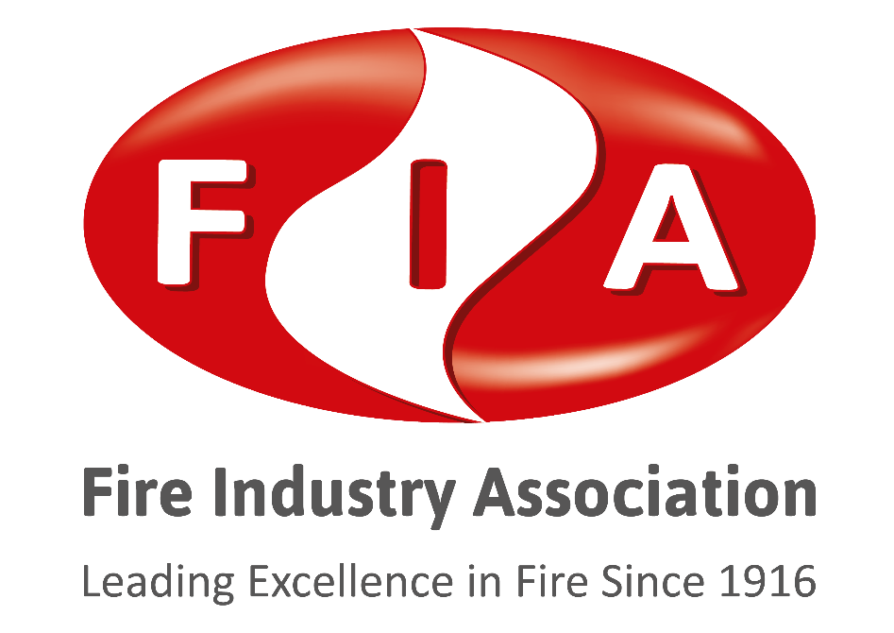

FIRE AND RESCUE SERVICES (NORTHERN IRELAND) ORDER 2006
FIRE RISK ASSESSMENT
PAS 79-2 Housing
Annex D Northern Ireland Template Periodic review of an existing
fire risk assessment

Copyright and Acknowledgement

The copyright of this template is owned by C.S. Todd & Associates Ltd.

The FIA would like to thank and acknowledge, Mr. Colin Todd, MBE, Managing Director of C.S. Todd & Associates, for providing permission to freely distribute this template.

This template is a reproduction of annex D of PAS 79-2. Users are authorized to use the template contained within this document, and to make an unlimited number of copies for their own use, without infringement of copyright. However, following the template within this document does not necessarily produce a compliant Fire Risk Assessment. There is a need the Fire Risk Assessment to be carried out by competent person and include appropriate commentary in each section.

Annex D (informative)
Model pro forma for documentation of a review of an existing fire risk assessment

D.1 This annex contains a pro forma for documentation of a review of an existing FRA in Northern Ireland. If the pro forma is properly completed by a competent person, the format and scope of the review will be suitable and sufficient to satisfy the recommendations in Clause 20.

D.2 The format of the documented review may vary from that shown in this annex, provided the recommendations in Clause 20 are satisfied. For example, the level to which principal issues are broken down into their component factors may vary, provided it is clear that the principal issues addressed in the original FRA have been addressed, or that the scope of the review is limited to, for example, a material alteration that has resulted in the review (see Clause 20).
NOTE A review of an FRA does not necessarily involve completion of a pro forma, but this annex offers a record of the review that may be made.

Template instructions:
The header and footer fields are locked and cannot be altered. Clicking in either of these fields can cause the cursor to jump to a later place in the document.
The NA/Yes/No boxes can be populated by clicking in the auto-complete field in the centre of the box, or by positioning the cursor outside the auto-complete field and entering your own choice of character.

FIRE AND RESCUE SERVICES (NORTHERN IRELAND) ORDER 2006
PERIODIC REVIEW OF FIRE RISK ASSESSMENT

Appropriate person (e.g. employer) or person having control of the premises:
Address of premises:
Person(s) consulted:
Assessor:
Date of this fire risk assessment review:
Date of full fire risk assessment that is under review:
Date(s) of full fire risk assessment review(s):
Review number (e.g. 1 or 2):
Suggested date for next review⁾:
OR
Suggested date for next full fire risk assessment:
The purpose of this report is to provide an assessment of the risk to life from fire in these premises and, where appropriate, to make recommendations to ensure compliance with fire safety legislation. The report does not address the risk to property or business continuity from fire.
[Date]

GENERAL INFORMATION
1. | Significant changes identified since the time of the previous fire risk assessment in respect of:
1.1 | The premises:
1.2 | The occupancy:
1.3 | The occupants (including occupants especially at risk from fire):
1.4 | Fire loss experience:
1.5 | Application of fire safety legislation:
1.6 | Other relevant information:

FIRE HAZARDS AND THEIR ELIMINATION OR CONTROL
2. | Significant changes in measures to prevent fire since the time of the fire risk assessment:
3.1 | Are there adequate measures to prevent fire? |  |  | Yes |  | No
3.2 | Comments and hazards observed:
4.1 | Are housekeeping and maintenance adequate? |  |  | Yes |  | No
4.2 | Comments and deficiencies observed:

FIRE PROTECTION MEASURES
5.1 | Significant changes in fire protection measures since the time of the fire risk assessment:
6.1 | Are the means of escape from fire adequate? |  |  | Yes |  | No
6.2 | Comments and deficiencies observed:
7.1 | Are compartmentation and linings satisfactory?⁾ |  |  | Yes |  | No
7.2 | Comments and deficiencies observed:
8.1 | Is there reasonable emergency escape lighting?⁾ |  |  | Yes |  | No
8.2 | Comments and deficiencies observed:
9.1 | Are there adequate fire safety signs and notices? |  |  | Yes |  | No
9.2 | Comments and deficiencies observed:
10.1 | Are the means of giving warning of fire adequate?⁾ |  |  | Yes |  | No
10.2 | Comments and deficiencies observed:
11.1 | Is the provision of fire extinguishing appliances adequate? |  |  | Yes |  | No
11.2 | Comments and deficiencies observed:
12.1 | Comments on other fixed fire protection systems:

MANAGEMENT OF FIRE SAFETY
13.1 | Significant changes in management of fire safety since the time of the fire risk assessment:
14.1 | Are arrangements for management of fire safety adequate? |  |  |  |  |  |  | Yes |  |  | No
14.2 | Comments and deficiencies observed:
15.1 | Are fire procedures adequate? |  |  |  |  |  |  | Yes |  |  | No
15.2 | Comments and deficiencies observed:
16.1 |  | Are the arrangements for staff training and fire drills adequate? |  |  |  |  | Yes |  |  |  |  | No
16.2 |  | Comments and deficiencies observed:
17.1 |  | Are the arrangements for testing and maintenance of fire protection systems and equipment adequate? |  |  |  |  | Yes |  |  |  |  | No
17.2 |  | Comments and deficiencies observed:
18.1 |  | Are there adequate records of testing, maintenance, training and drills? |  |  |  |  | Yes |  |  |  |  | No
18.2 |  | Comments and deficiencies observed:
19 |  | Are there continuing arrangements for the premises information box to be kept up to date? | N/A |  |  |  | Yes |  |  |  |  | No
20.1 |  | Are there continuing arrangements for engagement with residents? | N/A |  |  |  | Yes |  |  |  |  | No
20.2 |  | Comments and deficiencies observed:

FIRE RISK ASSESSMENT
On the basis of the criteria set out in the original fire risk assessment, it is considered that the current risk to life from fire at these premises is:
 | Trivial |  | Tolerable |  | Moderate |  | Substantial |  | Intolerable

ACTION ON PREVIOUS ACTION PLAN
Have all previous recommendations been satisfactorily addressed?
Yes |  |  | No
Brief details of recommendations not yet implemented.
1.

NEW ACTION PLAN
It is considered that the following recommendations should be implemented, along with any outstanding actions in the original fire risk assessment/previous review, in order to reduce fire risk to, or maintain it at, the following level:
Trivial |  |  | Tolerable
Definition of priorities (where applicable):
Item | Recommendation |  |  |  | Priority |  | Timescale
1.

⁾ The original fire risk assessment should be reviewed again, or a full fire risk assessment undertaken, by a competent person by the date indicated above or at such earlier time as there is reason to suspect that it is no longer valid or if there has been a significant change in the matters to which it relates, or if a fire occurs.
⁾ Based on a sample inspection of readily accessible areas.
⁾ Based on visual inspection only.
⁾ Based on visual inspection only.

